2023 Requirements for Junior

MMSTC Research and Innovation Project

I. Basic Formatting Requirement
- Written in third person past tense. Do not use “you,” “I,” etc. Procedures written in second person (Still, do not use “you” or “your”).
- Uniform font size 12 and legible font type (Times New Roman or Arial). Keep this consistent throughout your entire paper! Information on labels, charts, and graphs can vary between size 10 and 12. Consistency is key!
- 1.5 inch margin on the left, 1” on the other three sides
- Tables and figures are properly formatted, labeled, scaled, and anchored. Table and figure numbering must be sequential throughout entire research paper. Each must be anchored in text (paragraph form).
- Correct spelling and grammar always apply. No contractions.
- Research partners’ names are alphabetized and appear as headers with a hyphen between names (Cybulski-McMillan). Complete information is on title page.
- Use page numbering starting with the “Introduction” section as page 1.
- Page numbers are to appear in the header after partners’ names and one space.
- Start each section of the research paper on a new page. Each section title is in BOLD and centered; subsections are underlined with a colon after, do not underline the colon.
- Projects are to be original research or, with approval, extensions of previous research. All corrected rubrics and drafts must be submitted with final paper.
- Annotated Bibliography is not part of your paper but is used to develop your Review of Literature and provide information on designing your experiment and what to expect (see Appendix A for guidelines)

II. Research Paper Sections

- Title Page must be vertically and horizontally centered and include:

Title
Your Names in Alphabetical Order
Macomb Mathematics Science Technology Center
Class
Section #
Science Teacher / IDS Teacher / Calculus Teacher
Due Date (13 June 2023)
2. Abstract

The abstract consists of concise summary (no more than one page. It includes accomplished objectives, methods, results, and conclusions. The abstract helps the reader understand the relevance of the study. This page is NOT numbered and the title is the title of the paper and is centered.

3. Table of Contents

This section should consist of a complete table of contents listing all the parts of the paper and their correct page number. No page number or header needed.

- Introduction

This section sets the stage for your scientific argument. It places your work in a broad theoretical context and gives readers enough information to appreciate your objectives. A good Introduction ‘hooks’ its readers, drawing them into the project and its potential significance to the scientific community and/or the general population. Convince readers of the importance of your experiment. The writer must have a firm grasp of the aims, principal results and relevance of the research. You may find that the Introduction is easier to write after you have written other portions of your paper and have a clearer understanding of just what you are introducing. The last sentence of your introduction should be a thesis statement that clearly explains your objective(s).
Some questions to consider when writing an Introduction:
- What is your project about?
- What is the general procedure? (Briefly stated in paragraph form)
- How is your project of value to the scientific community?
- What are the practical applications of your research?

IMPORTANT POINT: The Introduction is about how your project fits into the global scientific perspective. The Review of Literature pertains to the SCIENCE that SUPPORTS your project.

5. Review of Literature

The purpose of this section of your paper is to discuss all the scientific information necessary to understand your topic. The Review of Literature includes an explanation of the progression of relevant research and related experiments in your field of study, and what methods were used by predecessors who have already studied this topic and the results of their work. Your Review of Literature should help you refine your problem statement, and give you a foundation from which to base you hypothesis and model your experimental testing. This is where you must educate the reader to the SCIENCE involved. You can diagrams and figures to help readers understand the science! Consider your target audience and define or explain any terms, formulas (see Appendix B for format) and concepts that are critical to understanding this section. For example, do not just state that a ball hits the target. You MUST explain the science of HOW this happens. How does the ball travel so that it hits the target.What forces are acting on it? What angle does it need to be at and why? Etc.

The Review of Literature should be long enough to be thorough and short enough to avoid repetition. (about 3 pages)

6. Problem Statement

Problem Statements will be reviewed by MMSTC staff prior to final approval. This should be a clear statement of the specific problem which was studied and the hypothesis made by your team. This part will consist of three labeled and underlined subsections:

Problem: A short, concise description of the problem.
Hypothesis: Generally one sentence in length, although it may be up to one paragraph. It is a statement of what is being tested, and generally takes the form of an If-Then statement.
Data Measured: You are to identify the independent and dependent variables, units of measure for each variable, and the intended statistical analysis. Write this section in complete sentences.
7. Experimental Design

This section is a detailed description of the materials used and the procedures employed and MUST include the three, separately labeled and underlined subsections:

Materials: List in either one or two columns.
Procedures: A detailed step-by-step approach used in the experimental investigation. (There will be only one step “3.”)
Diagram: Detailed, labeled diagram or photograph of experimental setup as required by science teacher.

(Any other relevant diagrams, photos, charts, tables, etc. should appear in appropriate locations throughout the paper. Make sure these are anchored in the text.)

8. Data and Observations

This is where you will directly report the raw data, converted data with a single sample calculation shown where appropriate, along with any observations you made during the experiment which may have impacted the quality of the results. Place observations in a table format as close as feasible to the data that they describe. Include photographs of the experiment in progress (either before and after pictures OR pictures of the experiment in chronological order, whichever is appropriate). You should show any formula used to calculate values shown in your data table with all variables defined. Show any preliminary calculations needed before data analysis in an Appendix. (See Appendix C for sample calculation format) This section does not interpret, compare, or contrast the data. It does not have conclusions.

9. Data Analysis and Interpretation

Use this section to calculate and report any statistical analysis you have performed with your data. This is where graphs, modeling, curve fittings, and/or statistical tests appear. Include a sample of all calculations for determining a derived value used in an appendix. See specific requirements for this section in Appendix A of this manual.

10. Conclusion

This section is the most vital section of your paper and deserves your utmost attention. It is used to summarize the general conclusions drawn from your experiment. Experimental strengths, scientific relationships, patterns, and arguments that you have been building up in your paper, all come together in this section. The length of this section is two to three pages.

- Briefly state your conclusion with an appropriate statistic or percent error. Specifically, tell the reader what your findings mean, supported with scientific and/or experimental evidence.
- Explain WHY the results occurred. Explain these results scientifically. Tell whether your results agree or disagree with current research you referenced in your review of literature and explain WHY.
- Discuss any weaknesses in the design of the experiment, and any sources of error that affected the results. You must go beyond human error and dig into the realm of science. Make no apologies or excuses; take responsibility for your conclusions and results (positive or negative)!
- How do your results impact the scientific community? What further research could be conducted to study the problem further or to improve upon the study of this problem? (Does not mean simply changing the variables.)

11. Acknowledgments

Express your appreciation to people who assisted you with your paper or research project. This page is optional.
12. Appendix

Page has a header and is numbered. Not all projects will require an Appendix.

13. Work Cited
Contains all references used in paper and should be presented in correct MLA style and support any parenthetical citation used throughout the paper.
Entries are double spaced; page has a bolded title and is numbered. Ten sources must be cited throughout your paper. Five must be peer reviewed and one must be your professional contact. As proof, an e-mail from the contact must be included as an appendix in your paper. See Appendix D for contact form.

Appendix A
What is an Annotated Bibliography?
An annotated bibliography is a list of citations to books, articles, and documents. Each citation is followed by two brief (usually about 150 words) paragraphs, descriptive (summary) and evaluative (critique). The purpose of the annotation is to assist you in writing your review of literature, designing your experiment, refine your problem statement and hypothesis as well as evaluating the relevance, accuracy, and quality of the sources cited.

Why Is This Useful?
An annotated bibliography provides specific information about each source you have found. As a researcher, you need to become an expert on your topic and have the ability both to explain the content and to assess the usefulness of your sources. Think of your annotations as part of a conversation with yourself. The annotated bibliography reminds you about potential topics to investigate, what might be worth investigating further and what might not be worth spending your time on. You want to give yourself enough information to understand basically what the article/topic is about and to make an informed decision about whether this source is credible.

A Good Annotated Bibliography Will:
- Encourage you to think critically about the content of the works you are using, their place within a field of study, and their relation to your own research and ideas.
- Prove you have read and understand your sources.
- Establish your work as valid and you as a competent researcher.
- Orient your study and topic in a continuing professional research.
- Provide a way for others to decide whether the source will be helpful to their research if they read it.
- Help you as a researcher determine whether you are interested in a topic by providing background information and an idea of the work going on in a field.
The Process:
Creating an annotated bibliography calls for the application of a variety of intellectual skills: concise exposition, succinct analysis, and informed library research.
First, locate and record citations to books, periodicals, and documents that may contain useful information and ideas on your topic. Briefly examine and review the actual items (start with the abstracts). Then choose those works that provide a variety of perspectives on your topic.
Format:
You will need 6 annotations, which may range from ½ -1 page each. Four sources must be peer-reviewed. For each annotation you must complete the following:
1. Cite the book, article, or document using MLA style. (See Purdue OWL)
2. Write a concise summary of the central theme and scope of the book or article IN YOUR OWN WORDS. Do not copy the abstract. The following are ideas to consider as your write your annotated bibliography:
- What are the main arguments, thesis, or hypothesis?
- Give a non-biased overview of the arguments and proofs/evidence addressed in the work and the resulting conclusion.
- When appropriate, describe the author's methodology or approach.
3. Critically appraise and analyze the sources for your specific purposes.
- Evaluate the source or author critically (biases, lack of evidence, objective, etc.).
- How is this source beneficial/useful to your project, why?
- State the credentials of the source or the publication.
Citations:
Follow this citation format for articles in scholarly journals: (See Purdue OWL)

Author(s). "Title of Article." Title of Journal, Volume, Issue, Year, pages.

Bagchi, Alaknanda. "Conflicting Nationalisms: The Voice of the Subaltern in Mahasweta

Devi's Bashai Tudu." Tulsa Studies in Women's Literature, vol. 15, no. 1, 1996, pp.

41-50.

Summary:
This article describes a rapid and effective method for identifying vegetable oils from a variety of fibers, including cotton. The method uses ethanol to wick the oil from the cotton fiber. Due to the organic composition of both the oil and the ethanol basic solubility rules are utilized. The author hypothesizes that this method of oil removal is 99% effective and maintains the integrity of the sample for analysis.
Critique:
The author uses a controlled comparative experimental method and has evidence from completing many replications of his experiment. The author is Dr. Frankenstein from the Cambridge Laboratories and published in the Royal Journal of Science. We are going to use some of his procedures in our experimental design, specifically steps 3, 5, and 7, and compare the results of our experiment to his results.

Appendix B

Example of Embedded Formulas in Text:

Plank gave the name quantum to the smallest energy that can be emitted or absorbed. He proposed that energy, E, of a signal quantum number equals a constant, h, times its frequency, ν.
E = h ν

Plank then set about….(Continue paragraph here).
If just a formula, be sure to define all variables in the text but formula is not labeled as a figure.

Example of Sample Calculations in an Appendix:

Formulas for all statistical tests should be shown and detailed in an appendix. Also a sample calculation should be given. For example, if you are performing a t test you would show the equation for it, next insert its numerical values then define each variable in the anchor.

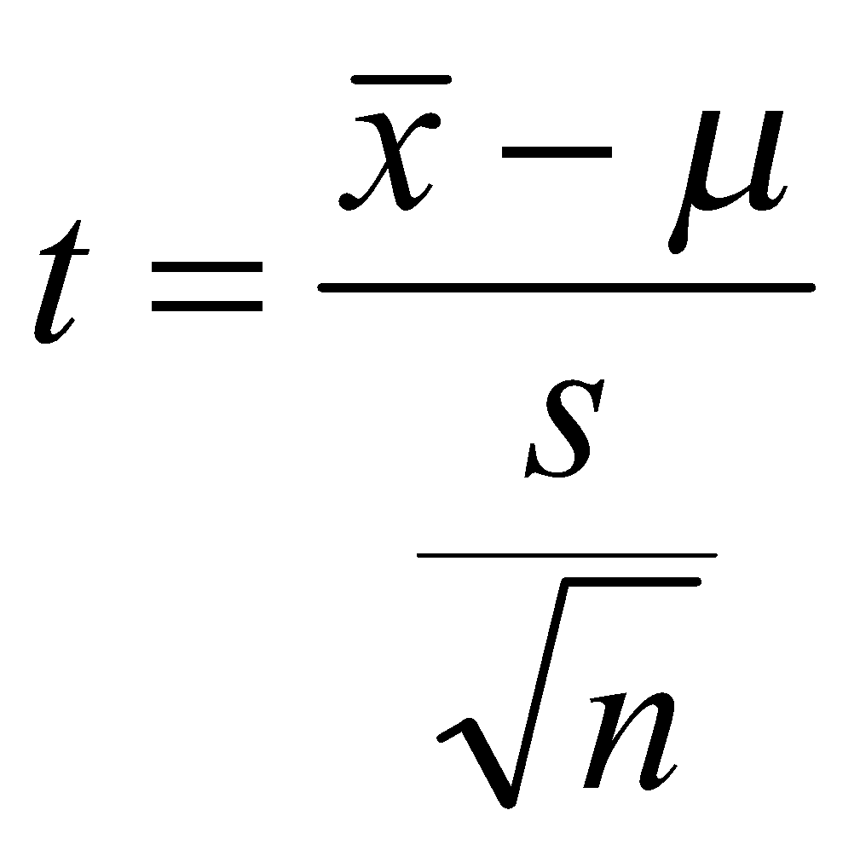

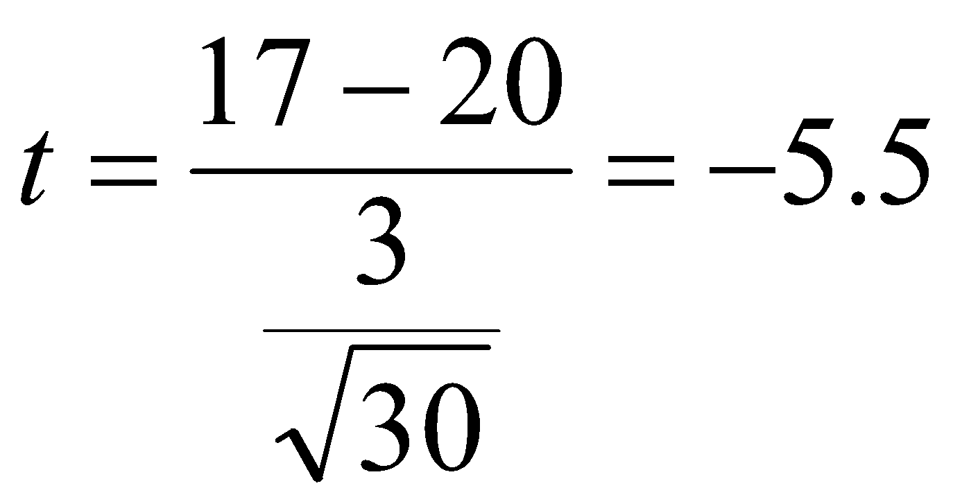

Figure 5. t Test Formula and Sample Equation

This equation calculates the value t which represents the number of standard deviations above or below the mean that data typically lie in a t distribution. The mean of the sample is represented by x̄. The true mean, mu, is represented by the symbol µ and is the value x̄ is being compared to; n represents the sample size and s represents the sample standard deviation.
Formulas for derived scientific values and a sample equation must also be included in an Appendix. For example, if you are trying to find the density of a certain metal but you are measuring the mass and displacement of water volume in your experiment you need to show how you calculated density from the final volume and mass that you recorded in your data table.

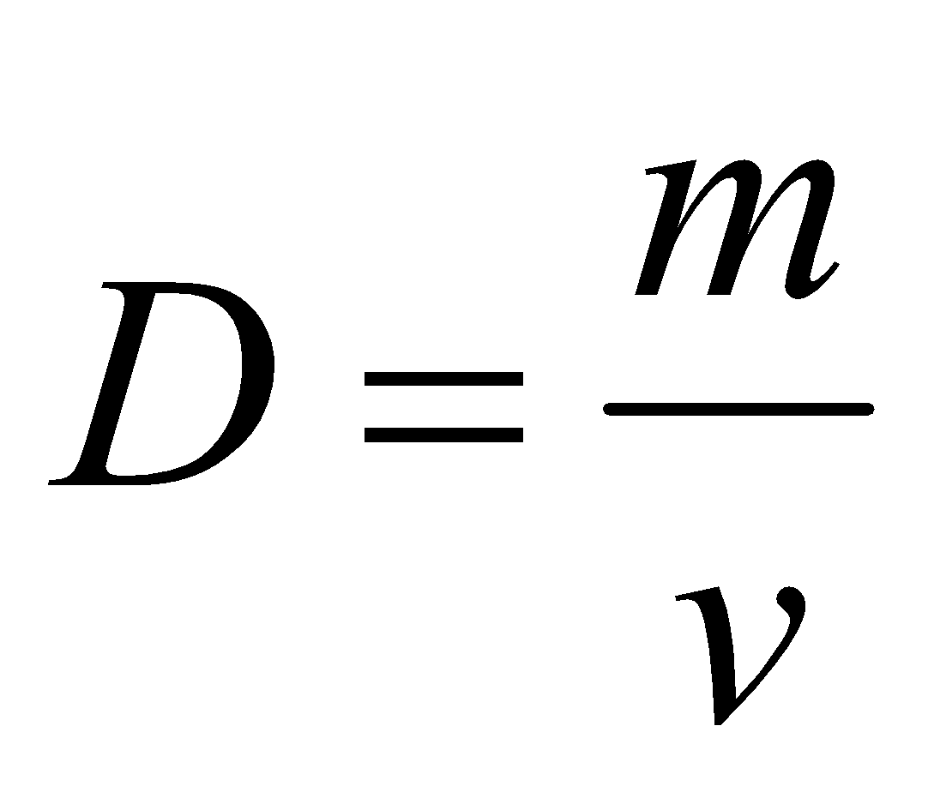
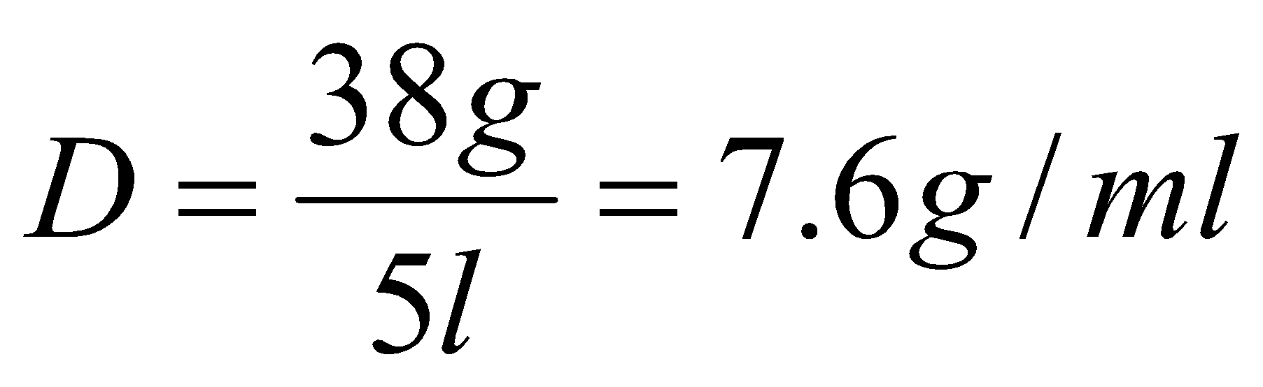
Figure 6. Density Formula and Sample Equation

The density of the element was calculated using the equation above, where D represents…
When the formula is accompanied by a sample calculation, box it and label it as Figure with an appropriate title. Be sure NOT to resize the box and skew the font in any way. Font should match the size of the text in the rest of the paper.

Appendix C
You have two options: DOE OR Descriptive and Another Statistical Treatment.

A. DOE:
(Use DOE packet in I:\MMSTC\Assignments\DOE Information as a MODEL--do NOT cut & paste!)

1. Clearly identify and label the high, low and standard values.
Factors | (+)  Values | Standards | (-)  Values

2. Include a table of all samples at each level (+++, -+-, etc.) for each DOE as agreed to on your contract, as well as the average at each level.
Level | DOE 1 | DOE 2 | DOE 3 | Average
+ + +
+ + -
The analysis is done on the average at each level.

3. Include a graph, table and comment for each of the single factors.

4. Include a graph, table and comment for each of the 2-factor interactions factors.

5. DO NOT include a summary page of all the effects.

6. Include a plot of standard points to look for trends and a comment about the plot.

7. Include a dot plot of all effects on a number line and comment on the effects that
were found to be significant.

8. Include the parsimonious prediction equation.

9. Save conclusions for section 10 of your paper.

B. Descriptive and Another Statistical Treatment:

1. After carefully thinking about and discussing an appropriate plot(s) for the data that was collected, include them (histogram, box plots, line graphs, etc…) in a powerful, useful way that will help to tell your scientific story visually. NOTE: Feel free to get help from staff as to which plot(s) make sense for the data.

2. Comment on any trends, patterns, etc. present.

3. Analyze mean & standard deviation of each set, if appropriate.

4. Find a model, if appropriate.

Specific requirements (see below)

One-sample t test
NOTE: Remember, if there are less than 30 data points, normality must be shown; if not normal, then a t test shouldn’t be used.
5. Clearly state the standard and the sample.
6. State the null and alternative hypotheses. Use mathematical notation and
identifying subscripts.
7. Show the graph and explain the p-value in relation to your problem (t test screen and graph).

Two-sample t test
NOTE: Remember, if there are less than 30 data points, normality must be shown; if not normal, then a t test shouldn’t be used.
5. State the null and alternative hypotheses. Use mathematical notation and
identifying subscripts.
6. Show the graph from the calculator and explain the p-value in relation to your problem (t test screen and graph).

Chi-Square
5. State the null and alternative hypotheses. Use mathematical notation and
identifying subscripts.
6. Include table of experimental values.
7. Include table of expected values & source of data.
8. Show calculation of chi-squared, degrees of freedom, and approximate p-value.
9. Interpret p-value in relation to your problem

ANOVA
5. Plot data and discuss spread within individual groups as compared to spread
between the groups.
6. State the null hypothesis and alternative hypotheses. Use mathematical notation
and identifying subscripts.
7. Show that you have met the assumptions.
8. Show calculations for and explain 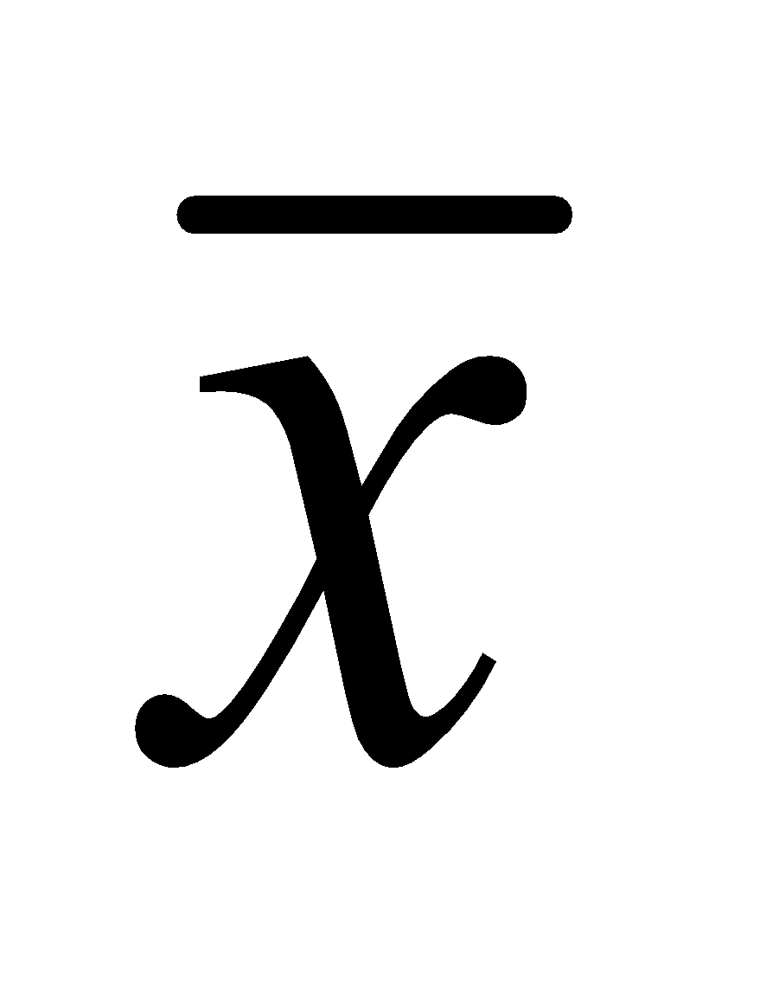, MSG and MSE in terms of your data (be sure
to define all variables).
9. Show F statistic, p-value, and interpret in relation to your problem.

Junior Research Contract
Names: ____________________________ _______________________________

Proposed Problem Statement:
_____________________________________________________________________
_____________________________________________________________________
_____________________________________________________________________

Brief description of your experiment:

_____________________________________________________________________
_____________________________________________________________________
_____________________________________________________________________
_____________________________________________________________________
_____________________________________________________________________
_____________________________________________________________________
Independent variable: ___________________________________________________
Dependent variable(s): ___________________________________________________
Number of trials: _______________________________
Detailed Plan for randomization. (Do not just state, “with my calculator.”)
_____________________________________________________________________
_____________________________________________________________________
_____________________________________________________________________
Proposed statistical treatment: (CHECK ALL THAT APPLY)
___ DOE OR___Descriptive AND ____1-Sample t Test ___ 2-Sample t Test ___Chi-Square ____ ANOVA ___ Other (Specify)

Describe why your choice is appropriate for your research.
______________________________________________________________________
______________________________________________________________________
______________________________________________________________________
Approvals:
Science Teacher_________________________ IDS _________________________
Math Teacher___________________________

Student _________________________ Student _________________________

